***User Manual: SkillSync web application***  
Version: 1.0  
Date: 18/02/2025  
Author: Group 33 (sjk50, aa1437, ae256, cl530, jc938, of48)  
Course: CO2302, 2025

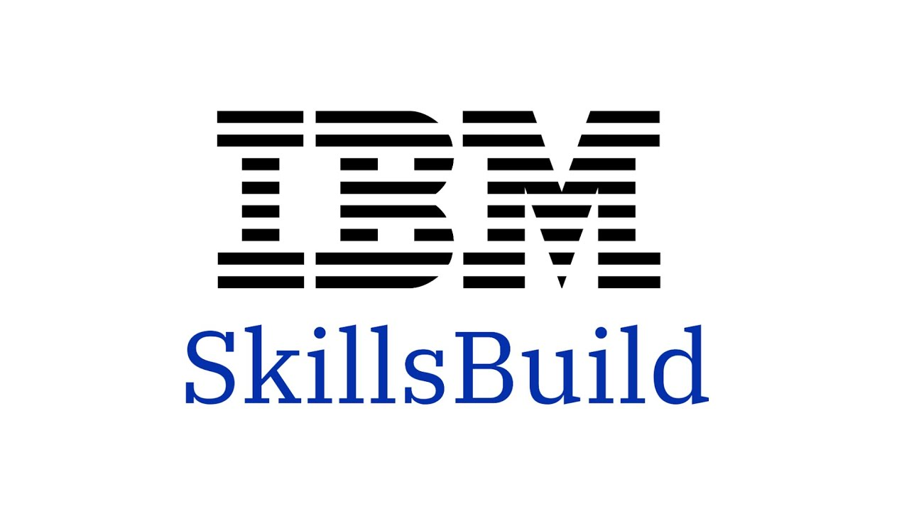

Table of Contents

1. Introduction 2

2. Key functionalities of the SkillsSync System: 2

3. Detailed description of the functionalities & a “How to” guide 3

4. Gamification Overview (check Glossary in Appendix for further information) 42

5. Maintaining the User Manual 42

6. Troubleshooting and FAQs 43

7. Appendix 43

# 1. Introduction

* This user manual provides step-by-step instructions for using the SkillSync web application in collaboration with IBM. new features/functionality adding new features as you develop them.
* SkillSync is designed to encourage users to engage with IBM SkillsBuild by offering a gamified learning experience(some examples include competing with friends, leaderboards, streaks).
* IBM SkillsBuild is a collection of online learning resources provided by IBM. These courses cover leading and emerging technologies, such as Artificial intelligence, Blockchain and Professional skills.   
  For more information, have a look at the official site of IBM SkillsBuild.
* Its features include course recommendations, certificate management, progress tracking, and user profile customization.
* This document is intended for end users and for guiding future development and testing efforts.
  1. Steps:
* Read through each section carefully.
* Follow the step-by-step instructions for each feature.
* Refer to the troubleshooting section if you encounter issues.

1.2. Troubleshooting:

* Ensure you are using a supported browser.
* Contact support if you continue to face difficulties.

# 2. Key functionalities of the SkillsSync System:

* SkillSync is an interactive web application with gamification that allows users to:  
   - Access a well-structured landing page, so that the user can quickly understand the purpose of the website and be directed to registration or login.  
   - Register and log in to the account, so that the user can have a personalised experience.  
   - View a dashboard to track a progress overview including streaks, completed courses, and leaderboard status.  
   - Search and filter courses by keywords and categories.  
   - Take quizzes (knowledge tests) to ensure learning and automatically earn certificates.  
   - Manage certificates with options to filter and sort them based on course’s main attributes (category, difficulty, keywords).  
   - Automatically recommend courses after obtaining certificates, based on user’s interests and completed courses so that user can find relevant learning materials.

- View learning history to track enrolled and completed courses.  
 - Edit account details including username, password and profile appearance to keep personal data up to date.

# 3. Detailed description of the functionalities & a “How to” guide

3.1 Landing Page

* Overview:  
   - Landing page has an overview of the site including sign up, login and dashboard links, FAQ and information section.  
   - The site includes navigation arrows for easy scrolling (bottom right).

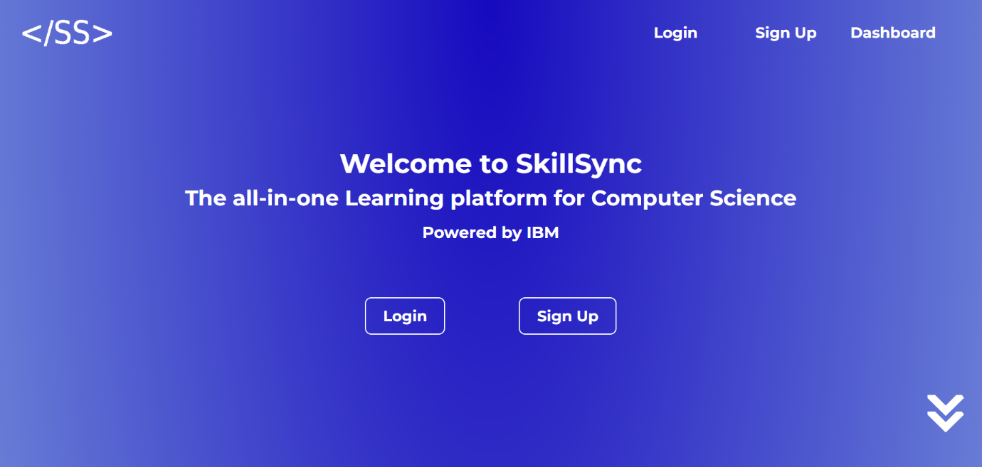

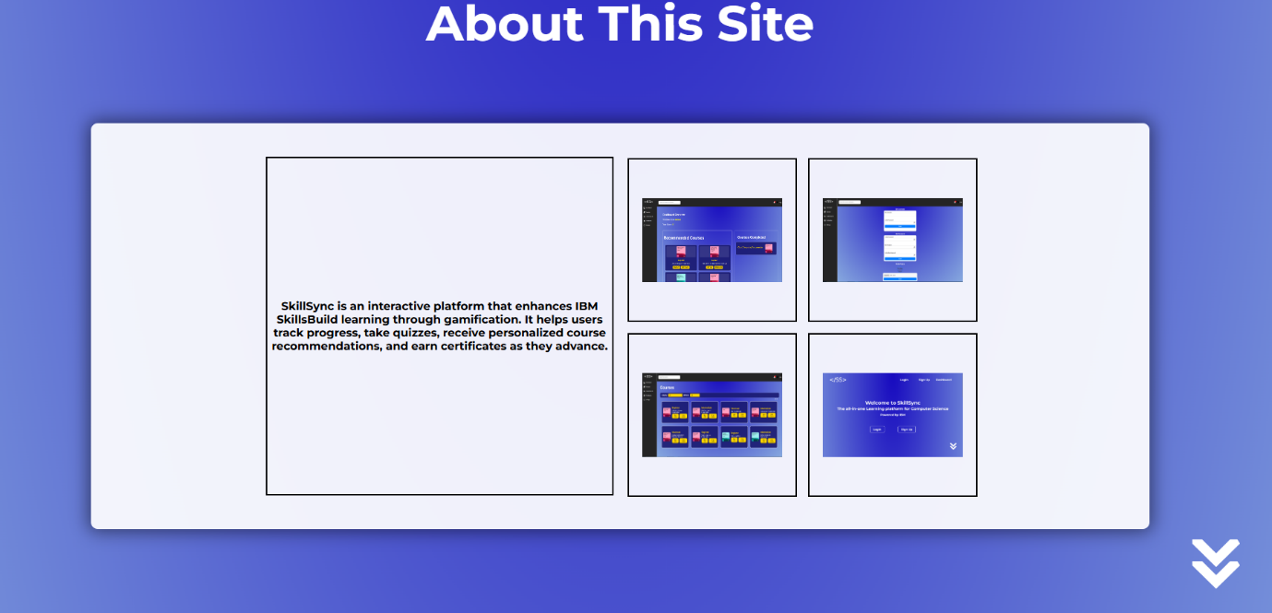

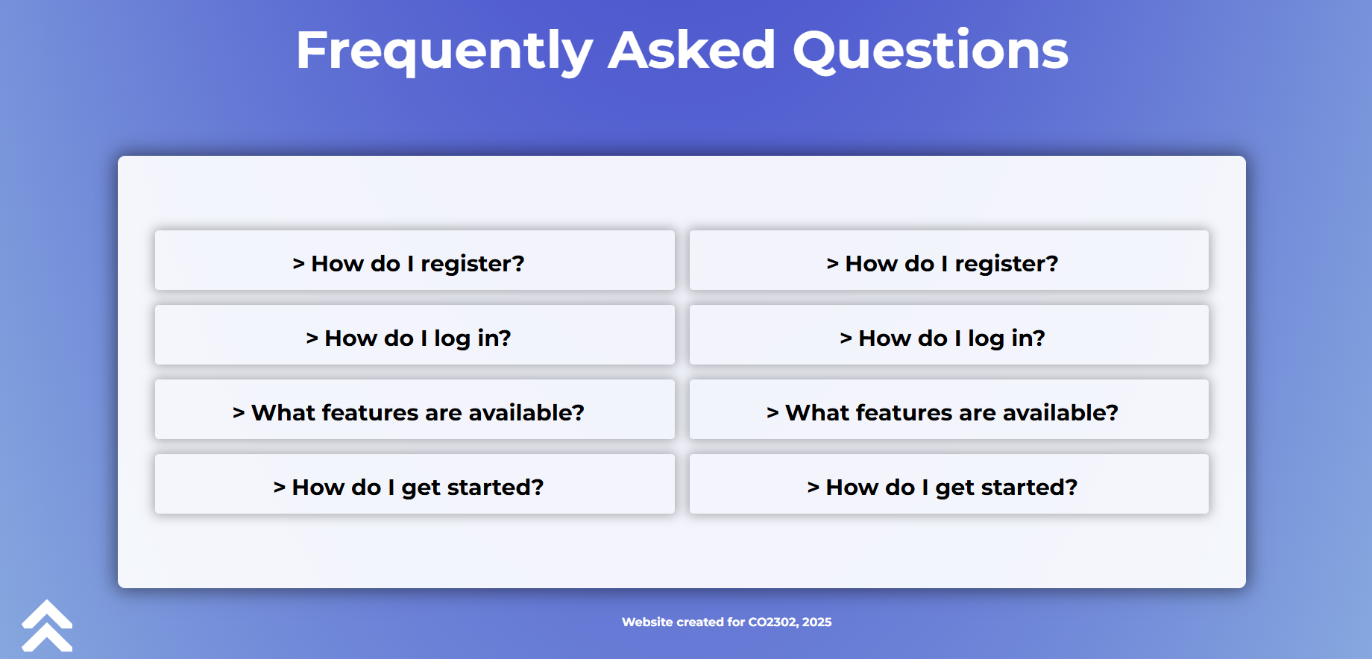

* Steps:  
   - Go to Log in or sign up: Click on the sign up or login button either on the centre or at the top of the page.  
   - Go to Dashboard: Log in, click the dashboard button at the top of the page.  
   - View FAQ at the end of the page:  
  Scroll down to the FAQ section and click on a question to view the answer.

-To go back on top, click on the arrows (bottom left).

* Troubleshooting:  
   - If the page does not load, reload the page.  
   - If you are unable to access the dashboard, you need to log in first.

3.2 Log In & Sign Up Page

* Overview:  
   - The log In and sign up page allows users to create an account and access their personalized experience.  
   - It provides fields for registration (name, email, username, and password) and a login page for returning users.  
   - The page is designed with clear input fields and validation messages.
* Steps:  
  - Register an Account:  
   - Click the "Sign Up" button from the landing page.  
   - Fill in the registration details with your name, email, username, and password.  
  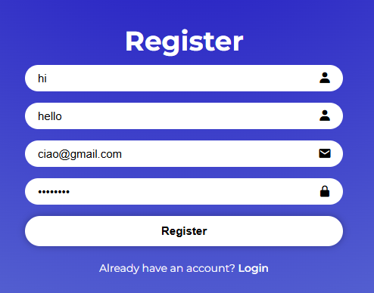 - Click "Register" to create your account.

-Log In:

- Once you are registered, it will redirect you to log in form.  
- Enter your username and password in the provided fields.

- Click "Sign In" to access your account.

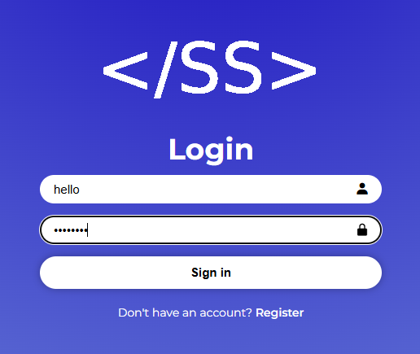

* Troubleshooting:  
  - If the page does not load, reload the page.

- If you receive an error message, verify that the required fields follow these rules: choose unique username and email, use correct format of email and follow the instructions for a safe password.  
- If login fails, double-check your credentials and ensure your account was successfully registered.

3.3 Viewing Your Dashboard

* Overview:

- The dashboard is your home page to track overall progress.

- Once you sign in with your profile, you will be able to view key information, including:

- enrolled courses – view courses that you have started learning

- available and recommended courses – View courses that you can enroll in based on your previous learning (if any)

- Streaks – Keep track of your consecutive active days (coming soon)

- Leaderboards – See how you rank against other users (coming soon)

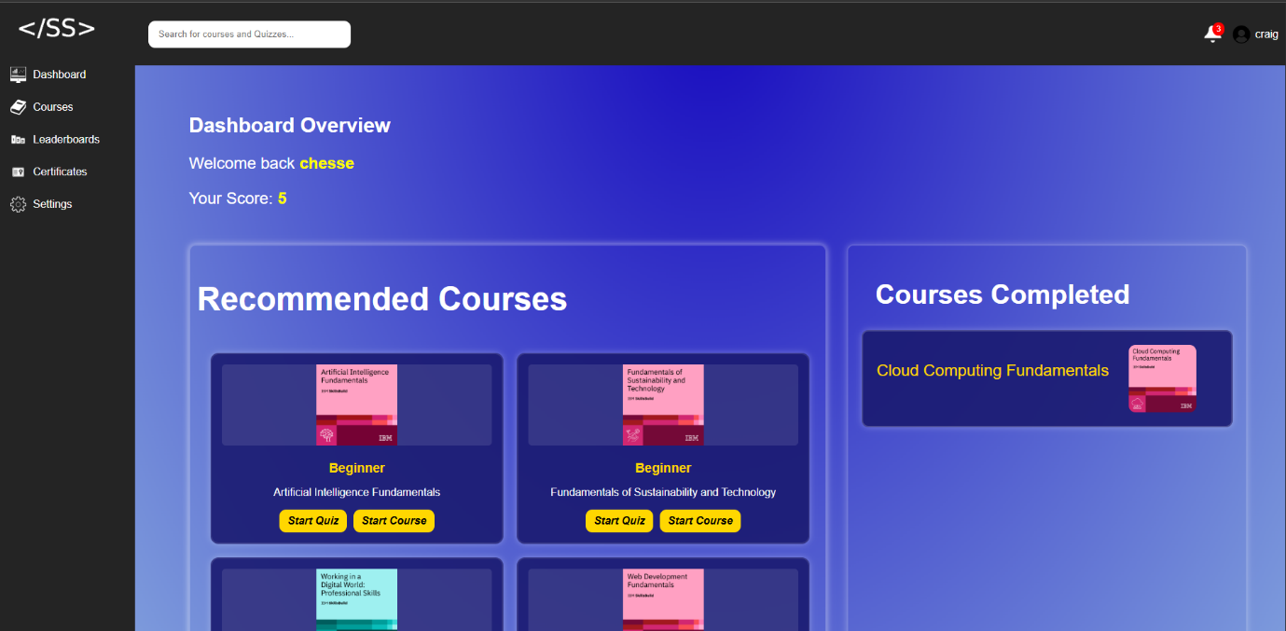

* How to Access Your Dashboard:  
  - Navigate to the Dashboard – After signing in, you will be automatically redirected to your dashboard.
* Features of the Dashboard:  
  - Available Courses:  
  - Lists courses that you can enroll in or continue.  
  - Displays course details such as title, difficulty.
* Dashboard Not Loading Properly:  
  - If the page does not load, reload the page.

-Try filtering or searching for courses.

- select the "Dashboard" option in the navigation menu or click on the SkillSync logo.

3.4 Search and Filter Courses

* Overview:

- Allows user to search and filter courses by keywords and categories.

* 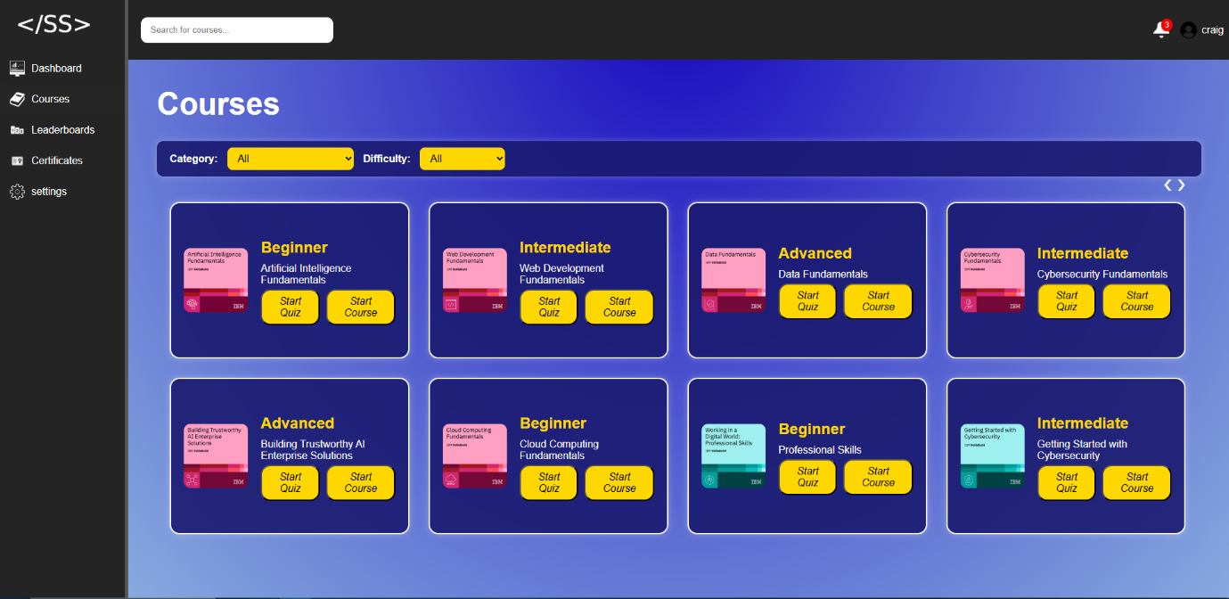Steps:  
   - How to Search for a Course:  
    - Locate the Search Bar at the top of the page, click on it to activate it.  
    - Begin typing the name of the course you are looking for or the category of the course.  
    - Once you submit search, the page will automatically update the search results to match your input.  
    - You will see relevant courses listed in real-time as you type.
* Filter Mechanism:  
   - How to Filter Courses by Category or Difficulty:  
   - On the page, locate the Filter Options section.  
   - You can filter by:  
     - Category: Select a category from the drop-down menu to view courses in that category.  
     - Difficulty: Select a difficulty level (e.g., Beginner, Intermediate, Advanced) from the drop-down menu to see courses with that difficulty.  
   - You can select either a category or difficulty, or choose both filters to narrow down the results further.  
   - Once you've made your selection(s), selection the option “Apply” and the page will automatically display the relevant courses based on the filters you applied.
* Example of Using Filter:  
   - Scenario 1: If you search for “Data Science” and filter by Intermediate Difficulty, the page will show all Intermediate Data Science courses.  
   - Scenario 2: If you filter by Advanced and AI category, the page will show all Advanced AI courses.
* Troubleshooting:

- If the page does not load, reload the page.

-If no results are showing, check your spelling.  
- Try a broader search if your search term is too specific.  
- if you have selected a category or difficulty level, but no courses are showing:  - Ensure there are courses available in your selected category or difficulty.  
- Remove some filters or try selecting a different filter.

3.5 Knowledge Test

* Overview:

- The Knowledge Test allows students to assess their understanding of course material through a quiz.

- Upon answering all questions and achieving a passing score (80% or higher), the system awards automatically a certificate and redirects to a success page.

* Steps:  
   - Start the Quiz:
  + Navigate to the desired course and click on "Start Quiz".
  + Complete the Quiz.
  + Select an option for every MCQ questions presented on the quiz page.
  + Click "Submit" to complete the test.
  + - View Results:

- If you pass (score ≥ 80%), you will be redirected to a success page, and a certificate will be awarded automatically.

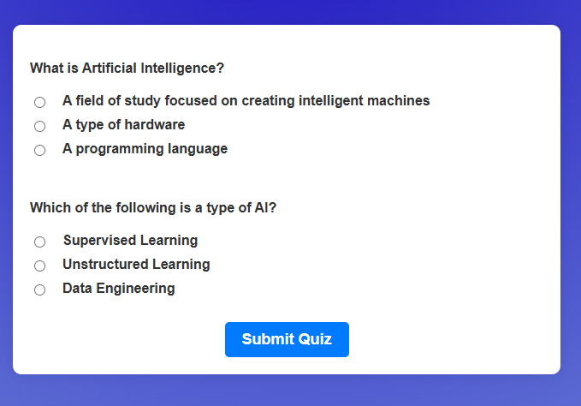

- If you fail, you will be redirected to a failure page with an option to retry the quiz.

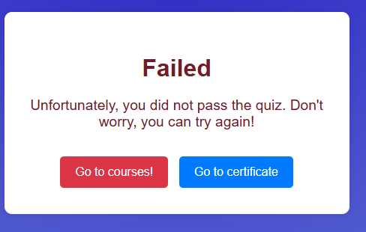

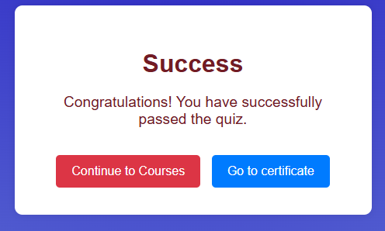

* Troubleshooting:  
  - If the page does not load, reload the page.

-If you cannot submit the quiz, ensure all the questions are answered.  
- If the page does not update after submission, refresh the browser and try again.

3.6 Certificate Order and Categories

* Overview:  
   - View your certificates with options to filter by course category (e.g., AI, Cyber Security, etc.) and difficulty (Beginner, Intermediate, Advanced), sort by the most recent issuance.
* Steps:  
   - Access Certificates:  
    - Click on “Certificates” from the side navigation.  
   - Search:  
    - Enter keywords in the search box to filter by course title.  
   - Filter:  
    - Select a category from the “Category” dropdown.  
    - Select a difficulty from the “Difficulty” dropdown.  
   - Sort:  
    - Ensure “Most Recent” is selected in the “Sort by” dropdown. Certificates will be ordered with the newest first.  
   - View Results:  
    - Submit your selections, and the certificates list updates to show only those matching your filters.  
    - Reset filters by clearing the selections.

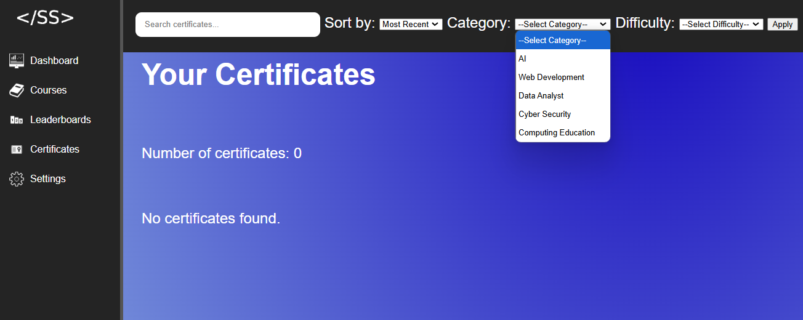

* Troubleshooting:  
   - If the page does not load, reload the page.

-If no certificates appear, verify if you have passed any quizzes.  
- Click “Apply” after changing filters to refresh the list.

-If no results are showing, check your spelling.

- Try a broader search if your search term is too specific.

- if you have selected a category or difficulty level, but no courses are showing:

- Ensure there are courses available in your selected category or difficulty.

3.7 Course Recommendations

* Overview:  
  - SkillSync recommends courses based on user’s interests and completed courses so that user can find relevant learning opportunities.

- The section dynamically updates on your dashboard to display relevant learning materials.

* Steps:

 - Access Dashboard: Log in and click the “Dashboard” button from the side navigation.

- View Recommendations: Scroll to the “Recommended Courses” section on the dashboard.

- Interact with Recommendations: Click on any recommended course to view more details or to enroll.

* Troubleshooting:

- If no recommendations appear, ensure that you have completed at least one course or set your interests in your profile.

- If the recommendations do not update, try refreshing the dashboard page.

3.8 Learning History

* Overview:

- View learning history to track enrolled and completed courses.

* Steps:

- Access History Log:

- Click on “Dashboard” from the side navigation.

- View your learning on the courses completed section



* Troubleshooting:

- If the page does not load, reload the page.

- If no courses appear, refresh the page or complete another course.

- if no courses are complete then the history will not display any courses.  
Follow these steps:  
 - Complete a Course:

- To view a course in your history, you must start learning it and complete the quiz.

- Select a course from the courses section, complete your learning and take the quiz.

- After passing the quiz, return to the dashboard home page.

- View the results when the learning history updates to show the course that you have completed.

3.9 Edit User Information

* Overview:  
   - The Edit User Information feature allows users to update their personal details and profile picture.

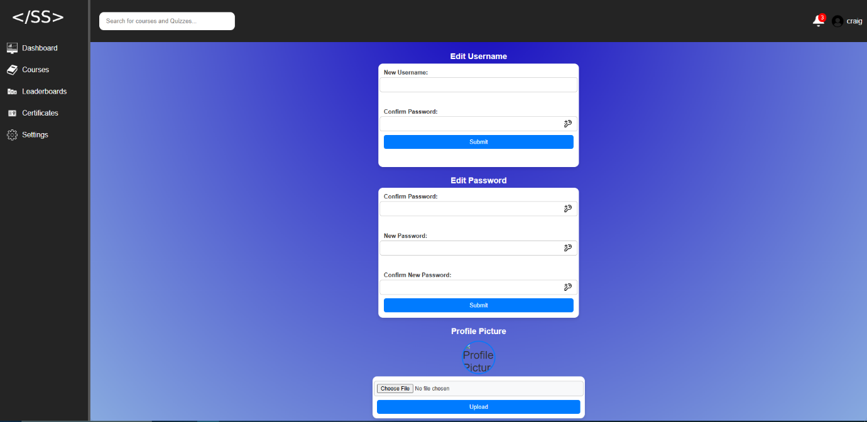

* Steps:  
   - Access Edit Profile:  
    - Click on "Settings" from the side navigation to open the edit profile page.  
    
   - Update Your Information:  
    - Edit the fields for your personal details (e.g., username, password) as needed.  
    - Optionally, upload a new profile picture using the provided file upload option.  
    - Click "Submit" to save your changes.
* Troubleshooting:  
  - If the page does not load, reload the page.

-If you see validation errors, check that all required fields are correctly completed and that the data format is correct (e.g., proper email format).

- If the update fails, try refreshing the page and re-entering your details.

3.10 Friendship System

* Overview:

The Friend System allows users to connect with others by sending and receiving friend requests. It provides a structured way for users to manage their connections within the platform, enabling interaction and engagement.

* Users can search for other users and send them a friend request.
* The recipient of a friend request has two options:
  + Accept the request: If accepted, both users are added as friends in the database, establishing a connection that allows them to view each other’s details.
  + Reject the request: If rejected, no connection is formed, and the request is removed from the system. The sender can send another request in the future if needed.
* Once a friendship is established, both users can see each other’s profile information, including usernames, scores, and profile pictures.
* Users also have the option to remove a friend at any time by clicking the Remove Friend button. When a friend is removed, the connection is deleted from the database, and the users will no longer have access to each other's details.

STEPS:

Navigating to the Friend System:

* Go to the navigation bar and click on "Friends."
* Upon clicking, the system will display a welcome message:  
  “Friend System – Connect with your friends, send requests, and manage your network.”
* The Friend System page is divided into three sections:
  1. Add Friends – Search for users and send friend requests.
  2. Pending Friend Requests – View and respond to incoming friend requests.
  3. Your Friends – See a list of all your accepted friends.

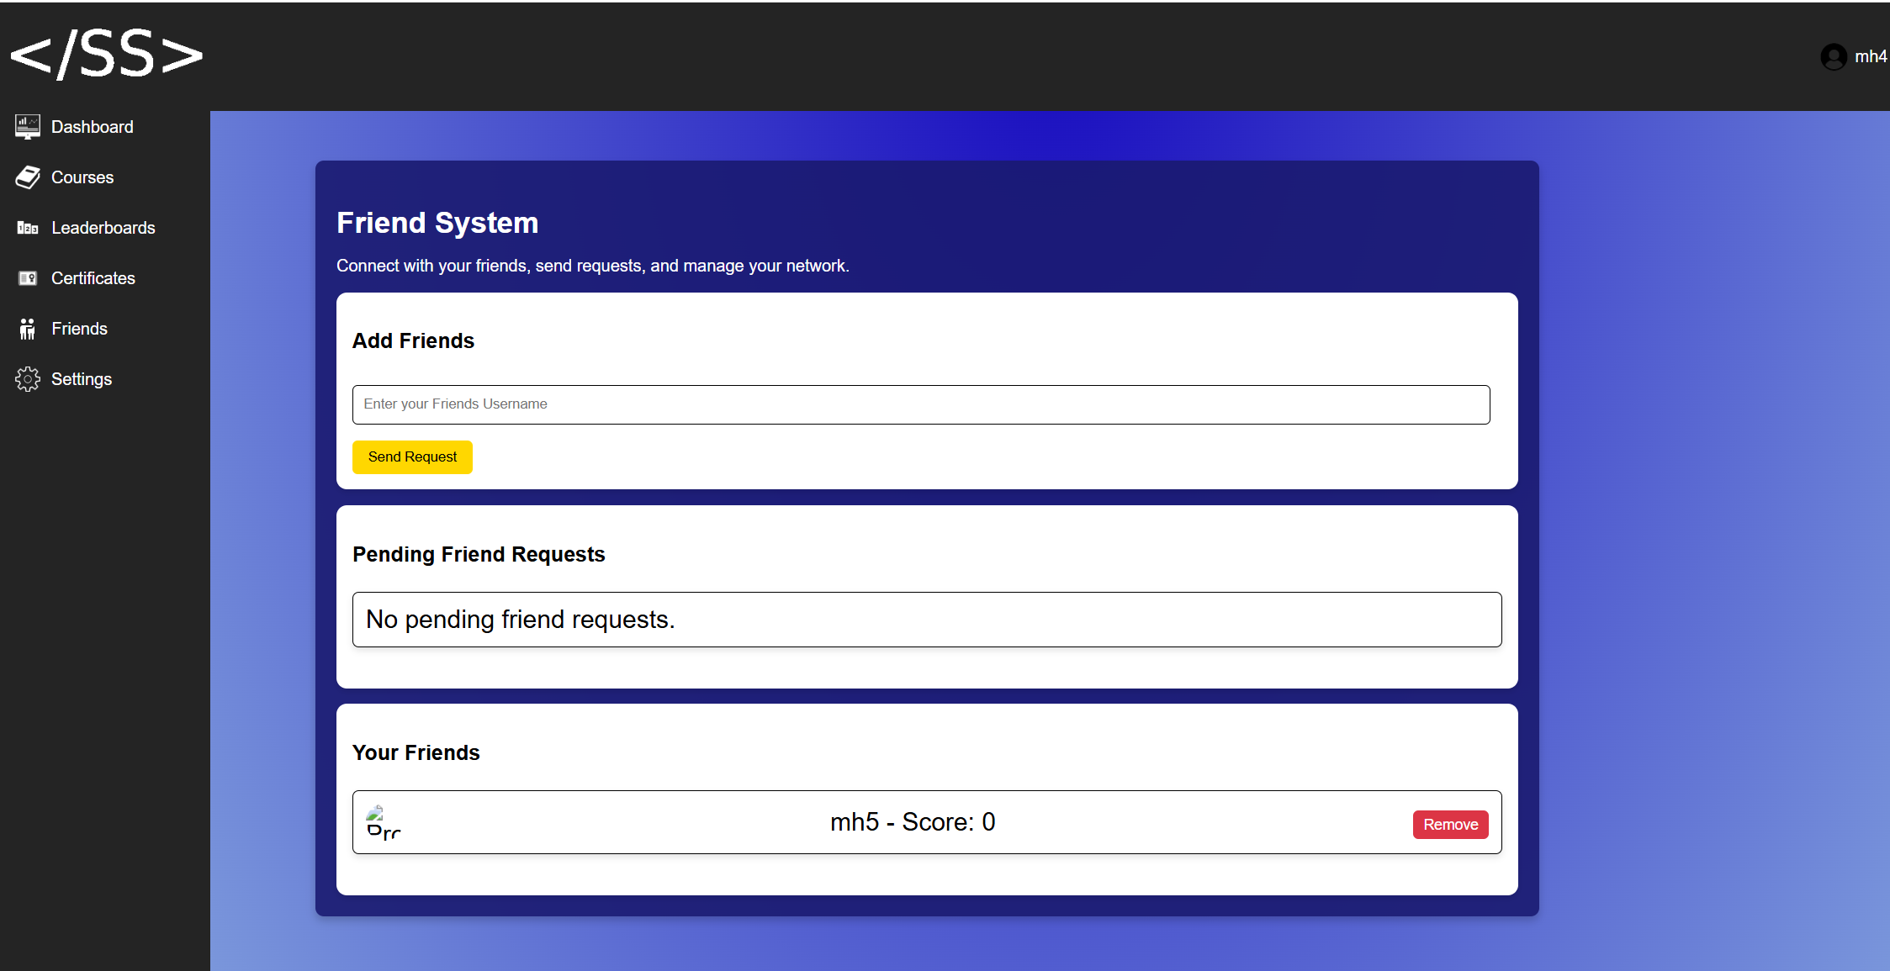

Sending a Friend Request:

1. Enter the username of the user you want to send a friend request to in the input box.
2. Click on the "Send Friend Request" button.

Possible Outcomes:

* Empty Input: If no username is entered, a popup message will appear stating:  
  "Please enter a username."

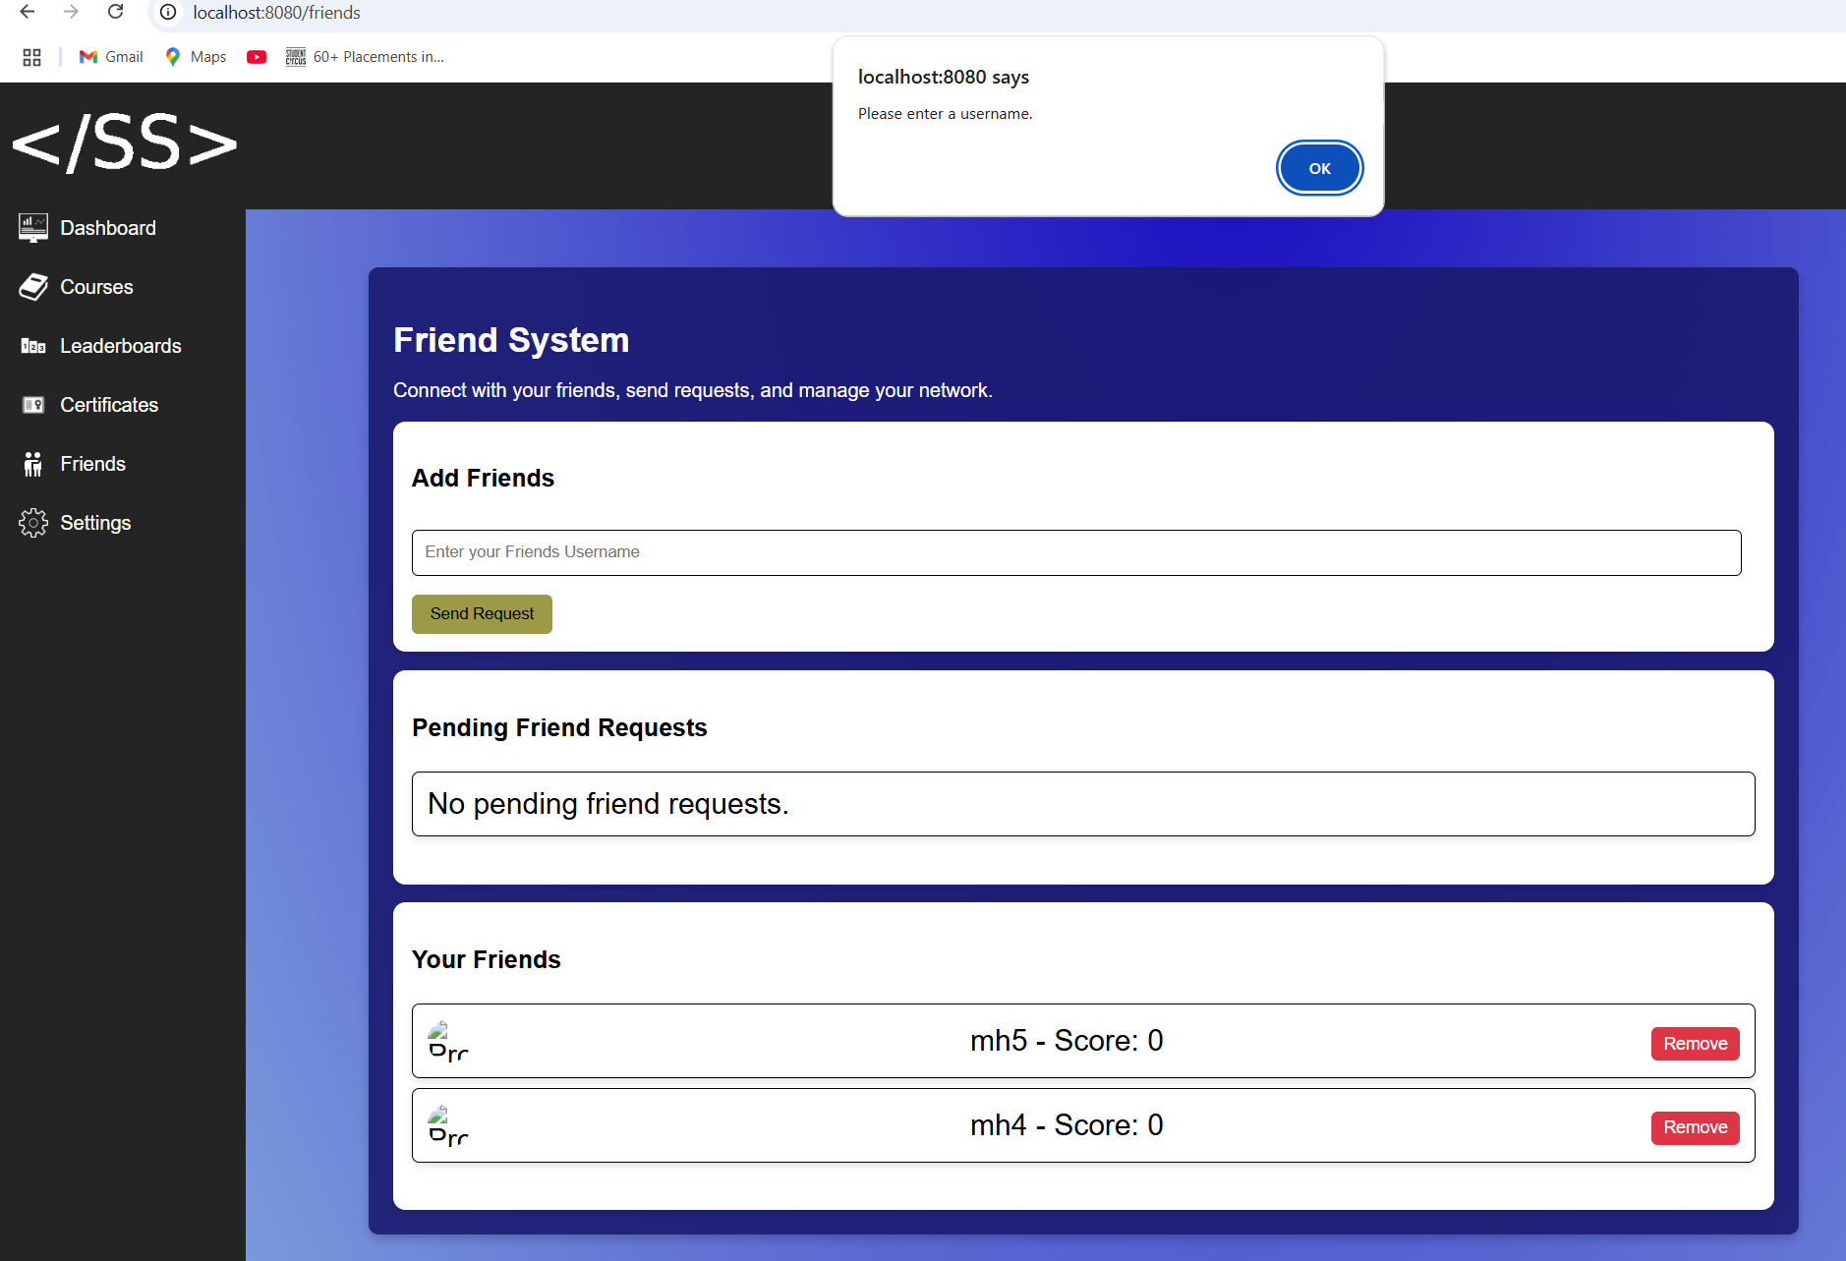

* User Not Found: If the entered username does not match any existing user, a message will appear:  
  "Receiver not found."

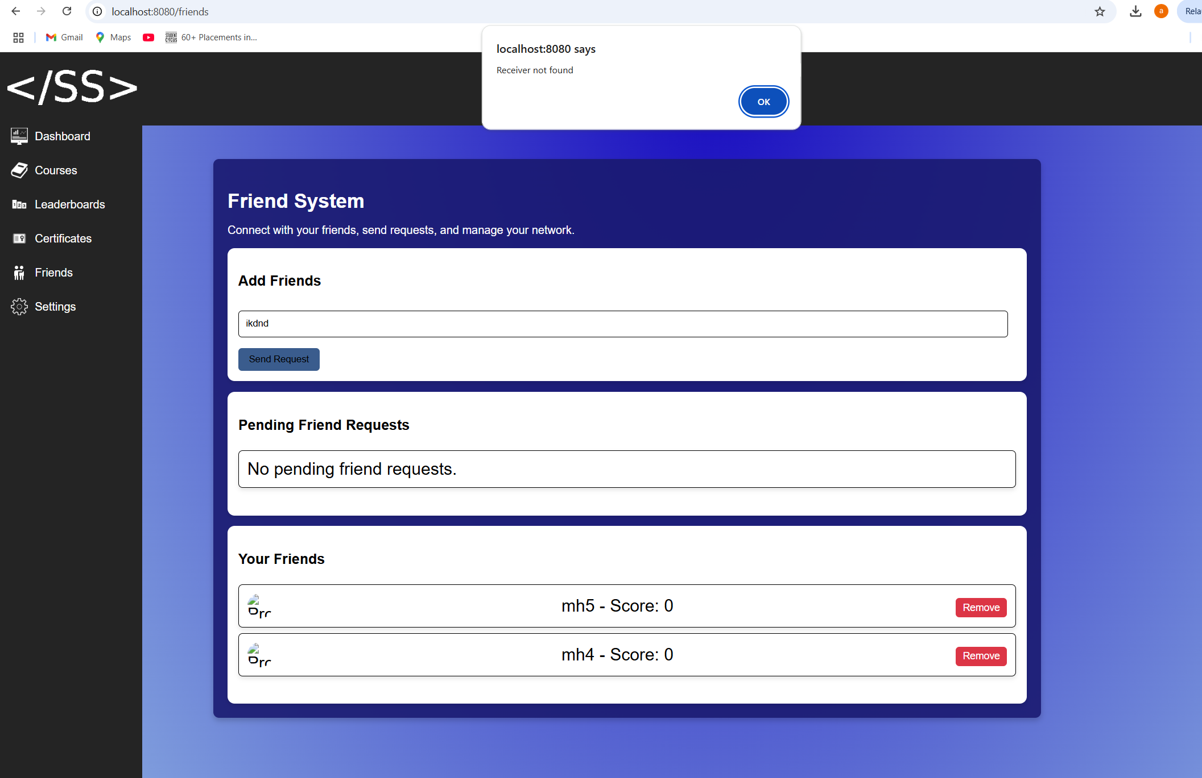

* Successful Request: If the entered username is valid, the system will send the request and display:  
  "Friend request sent!"

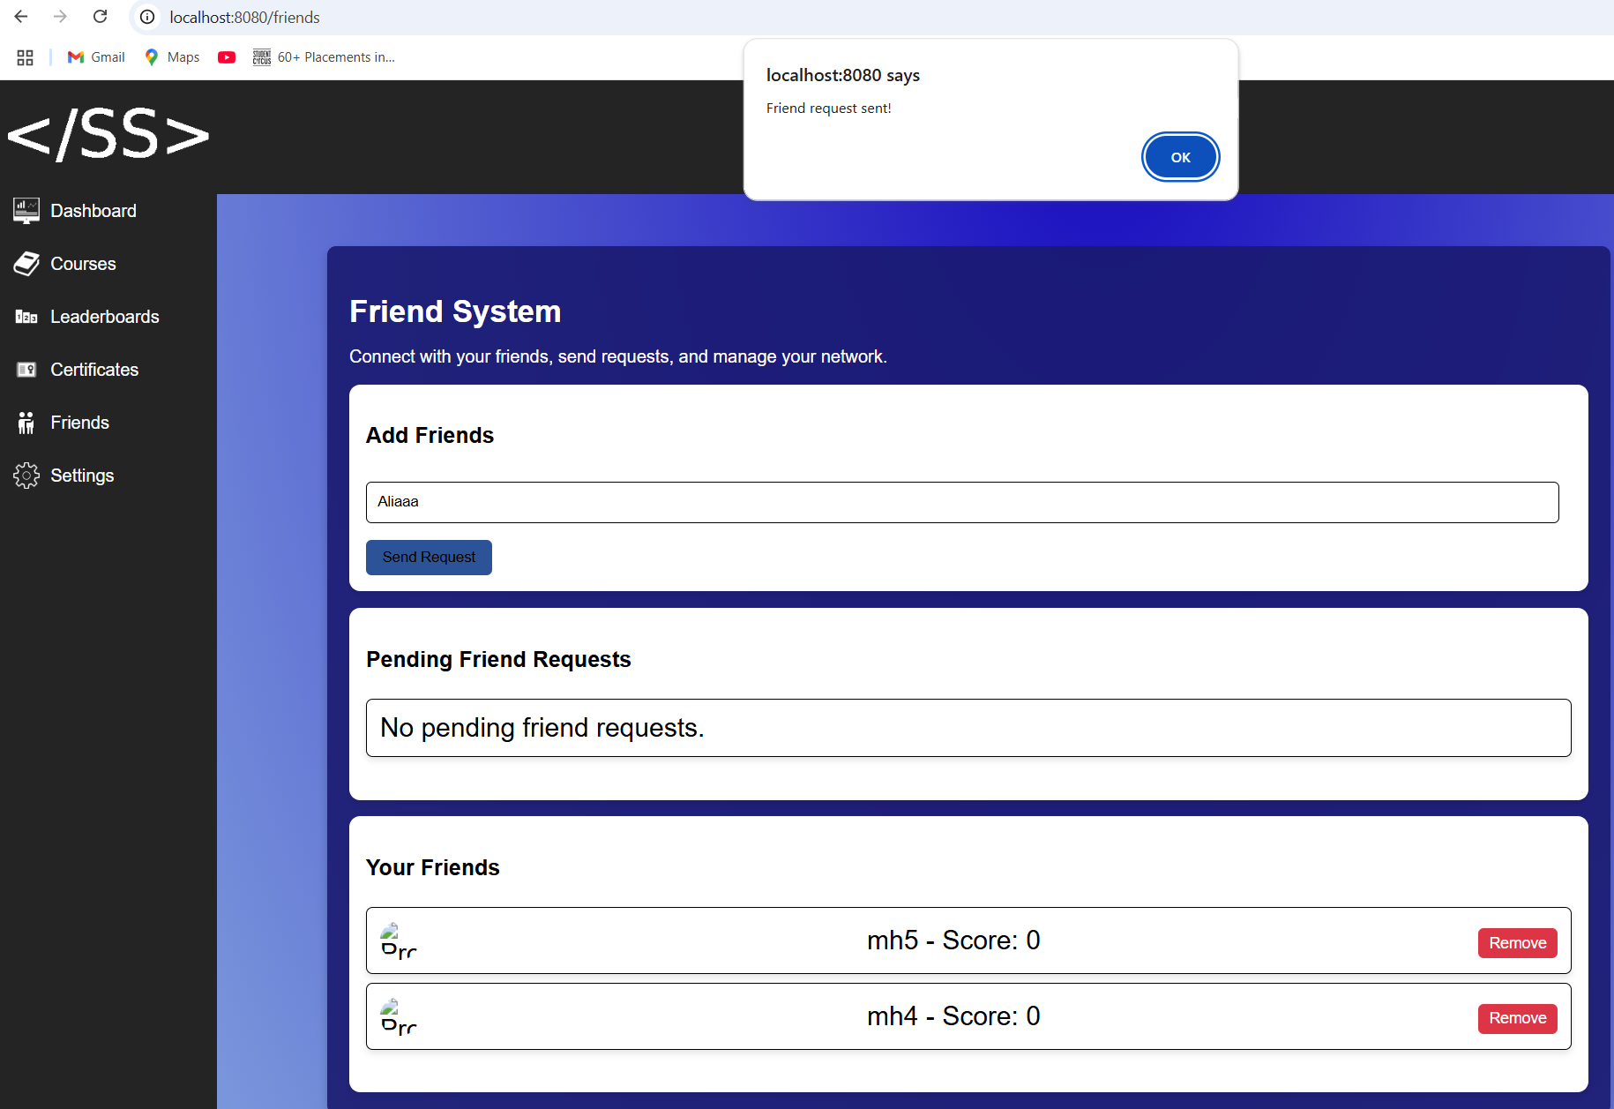

* Duplicate Request: If a friend request has already been sent to the same user, the system will display:  
  "Friend request already sent!"

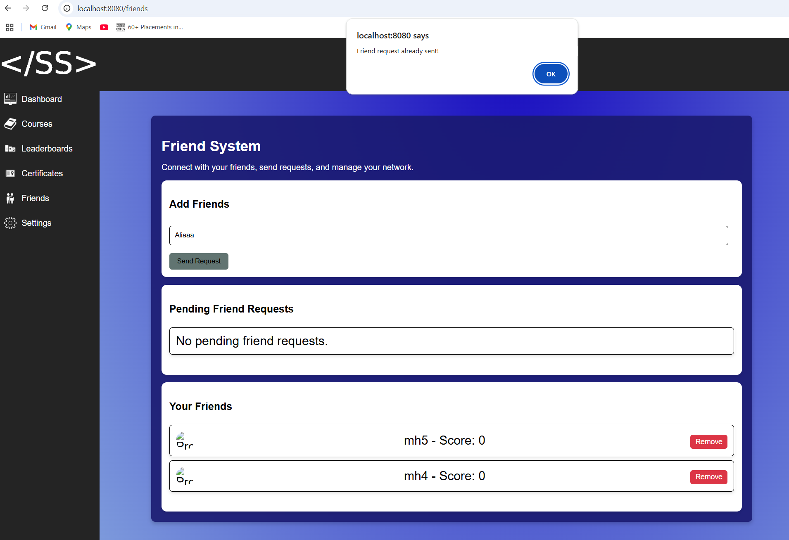

Receiving Friend Requests

In this section, the user can see if there are any pending friend requests from other users.

* If there are no pending requests, a message will be displayed:  
  "No pending friend requests."

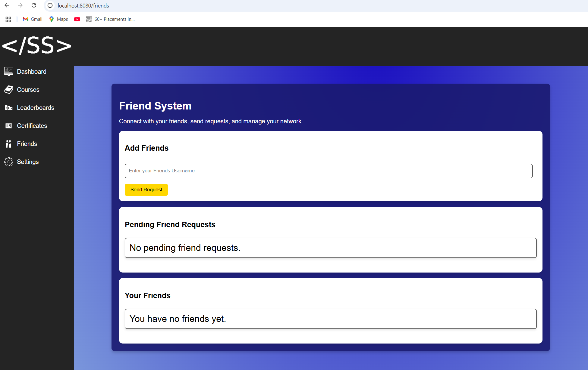

* If there are pending requests, the user will see the username of the person who sent the request.
* The user must choose between Accept or Reject the request.

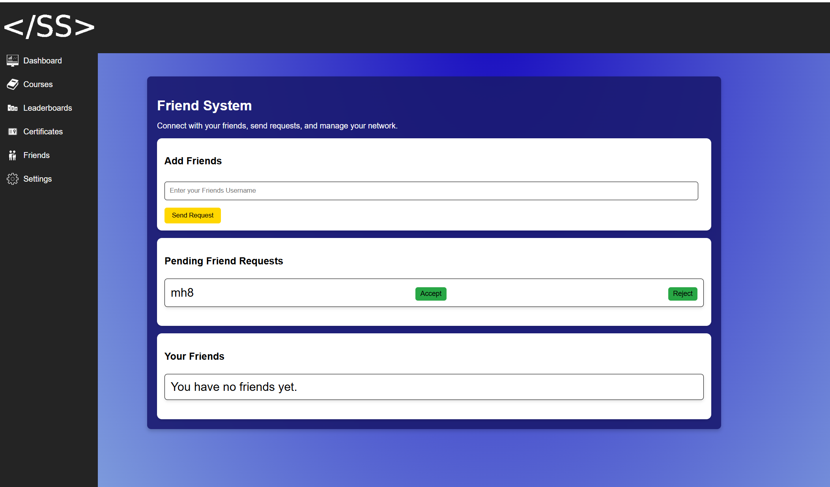

If the user rejects the request:

* The friend request will be removed.
* A message will appear:  
  "Friend request rejected!"

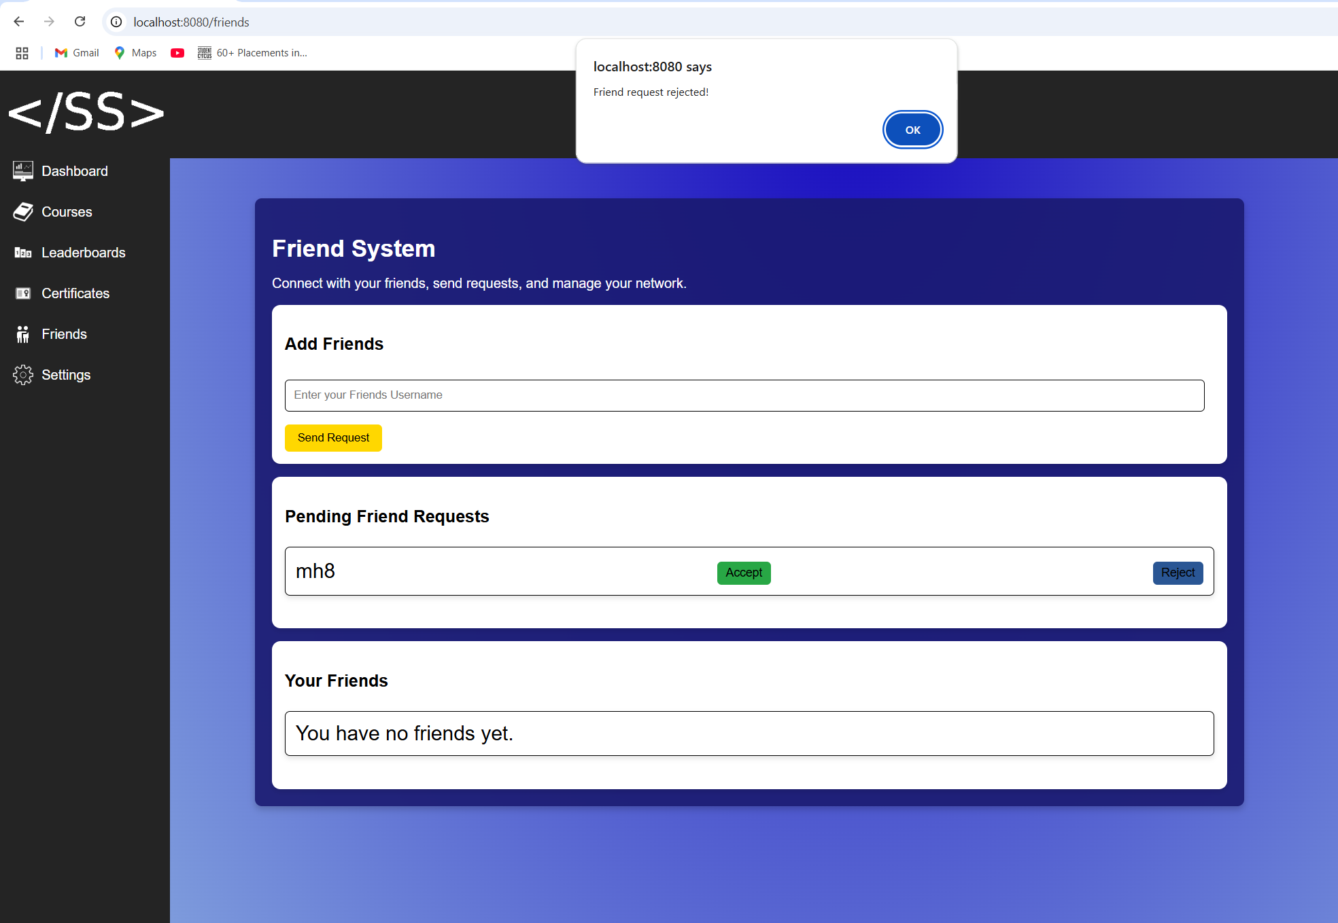

If the user accepts the request:

* The sender will be added to the user’s friend list.
* A message will appear:  
  "Friend request accepted!"

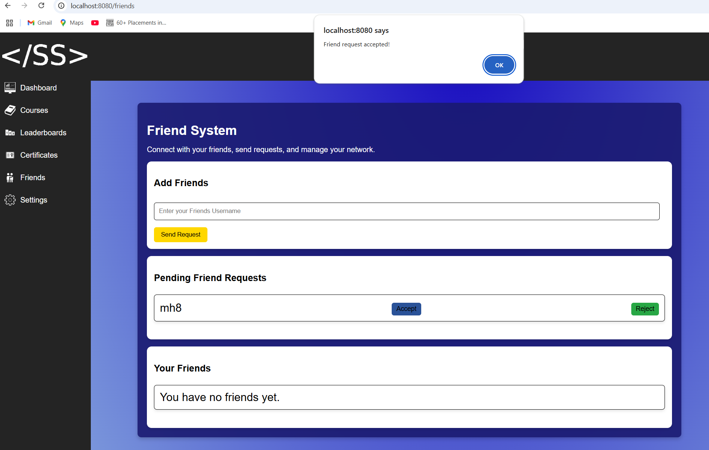

Viewing Your Friends

After a friend request has been accepted, the user can view their friends in the Friends section.

* Each friend will be displayed with the following details:
  + Profile Picture
  + Username
  + Score

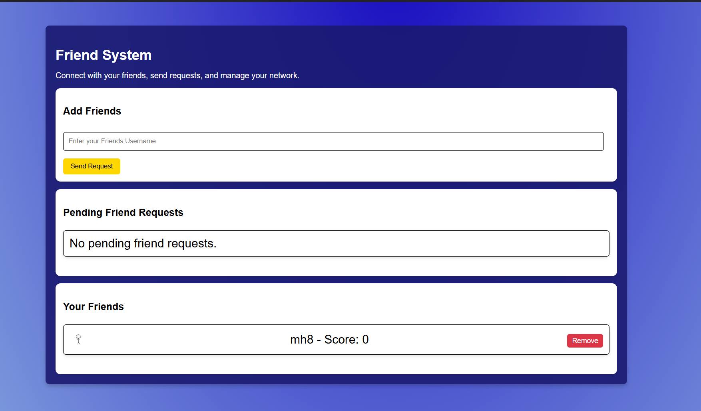

Removing a Friend

* In the Your Friends section, users can see a list of their current friends.
* Each friend will have a "Remove Friend" button next to their name.
* Clicking "Remove Friend" will pop up a message asking the user, “Are you sure you want to remove your username?”
* If the User presses No they will stay friends
* If the User presses Yes, they would be friends anymore

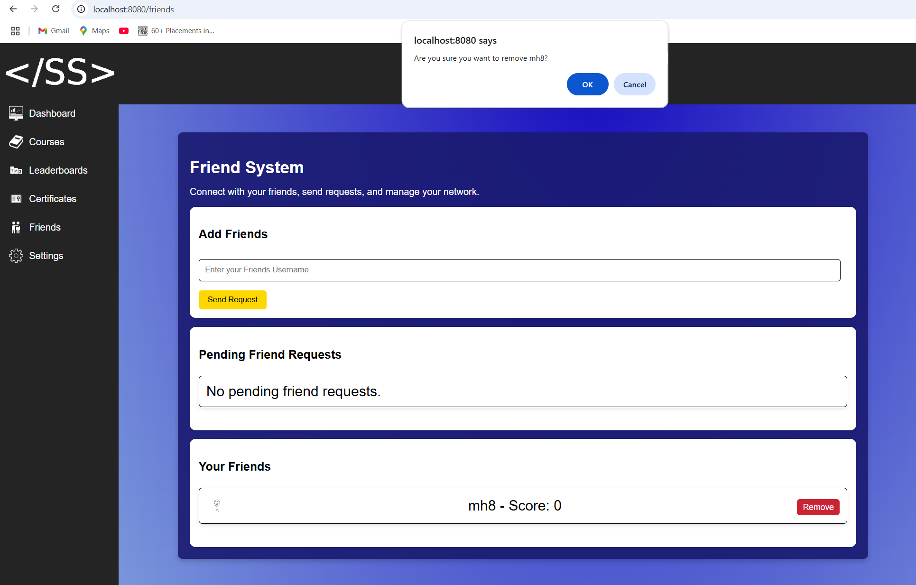

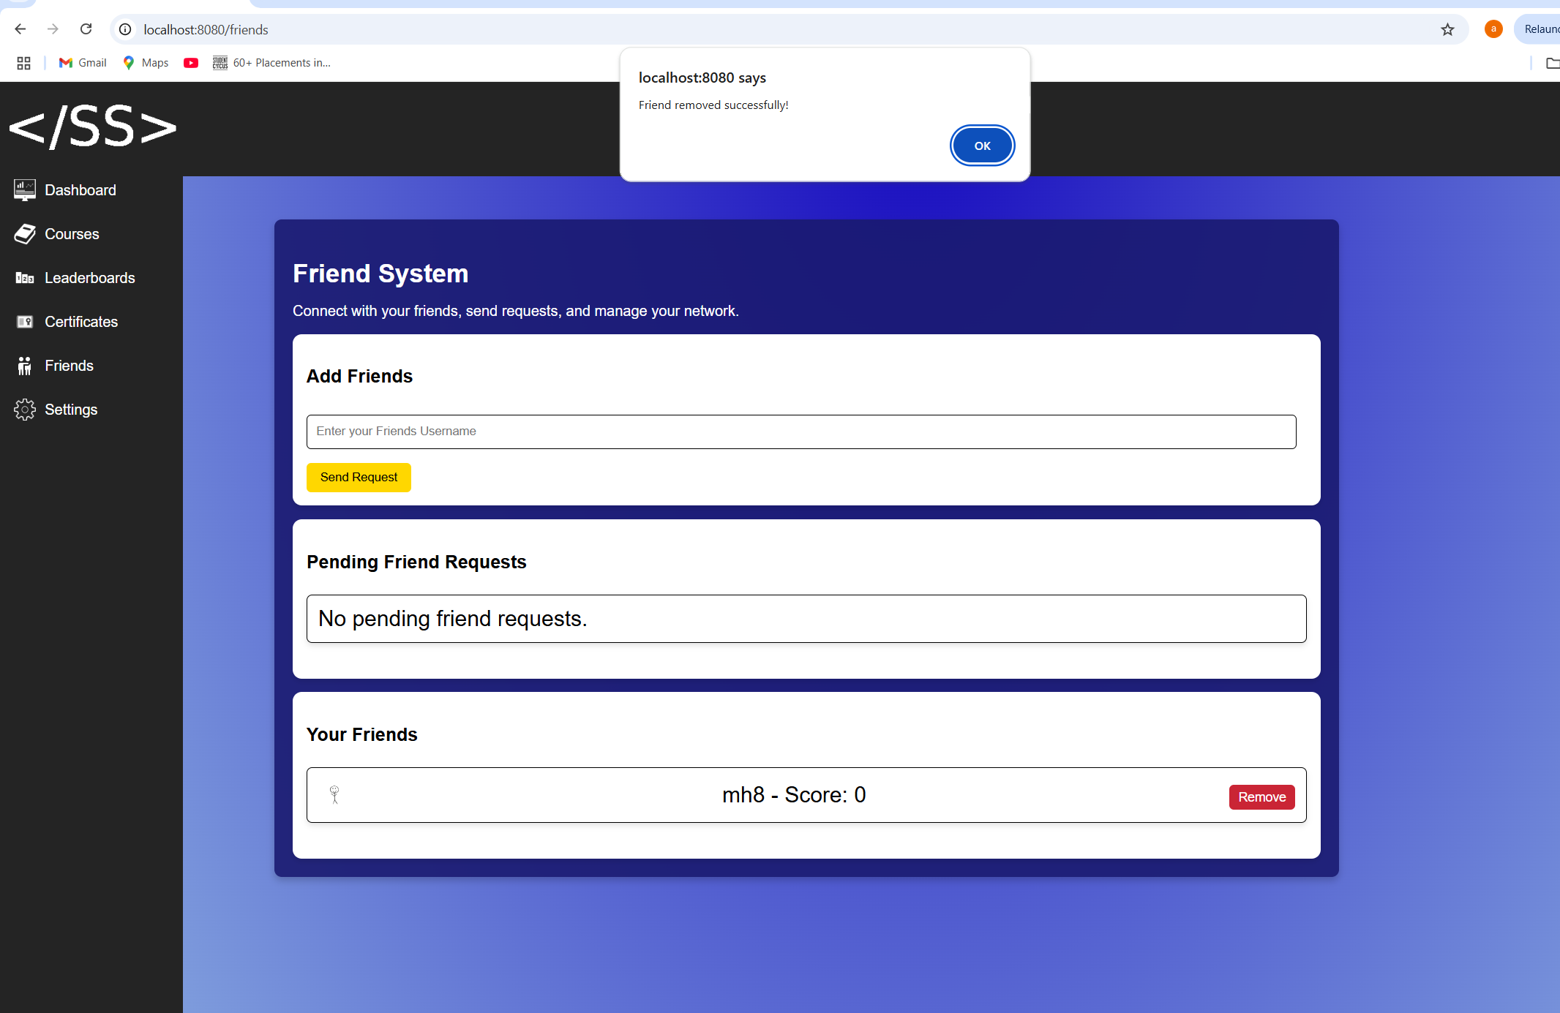

TROUBLESHOOTING:

* If the Friends page does not load, try reloading the page.
* If pending friend requests do not appear, refresh the page or check if any requests were sent.
* If a sent friend request is not showing, ensure the username entered was correct.
* If a friend does not appear in the list, follow these steps:

Follow These Steps:

1. Check Pending Requests:
   * If you sent a friend request, wait for the other user to accept it.
   * If they haven’t responded, the request will stay in the Pending Requests section.
2. Ensure the Request Was Sent:
   * If no request appears, try sending it again.
   * Ensure the username entered is correct.
3. Accept the Friend Request:
   * If you received a friend request, accept it at Pending Friend Requests.
   * Once accepted, the user will move to your Friends list.
4. Refreshing the Friends List:
   * If a friend does not appear after accepting the request, refresh the page.
   * Check if they have been removed accidentally.
5. Reconnecting with a Friend:
   * If you accidentally removed a friend, send them a new friend request.

3.11 Streaks

Overview:

The user will be able to maintain a streak by logging in daily.

Steps:

**Maintain streak:** Log in daily, making sure that they visit the dashboard each day.

**View streak:** Log in, visit the dashboard to see the streak counter

Troubleshooting:

* If the user forgets to log in for a day, their streak will reset to 1 and they will have to build it up again
* The streak is done by day, not 24 hours, so the user must keep this in mind when trying to maintain their streak

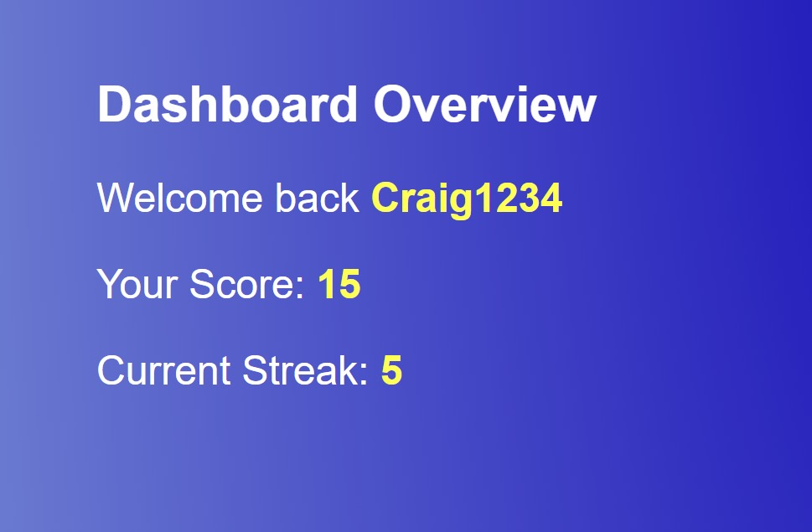

3.12 Badges

Overview:

The badges system allows users to track their achievements based on course completion and earned points. Users can view their current badge, explore all available badges, monitor their progress towards the next badge, and see which badges are locked or unlocked. The system updates dynamically when new badges are earned.

Steps:

**Viewing Your Current Badge**

1. **Log in** to your account.
2. Navigate to the **dashboard** page.
3. Your **current badge** will be displayed at the **top of the page**, showing the badge image and name.

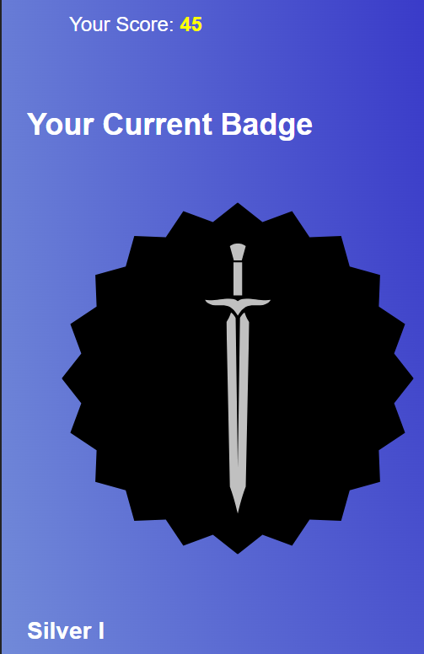

**Exploring All Available Badges**

1. Navigate to the **badges page**.
2. Scroll down to see the **badges grid**, which categorizes badges into **Tier I and Tier II** (e.g., Bronze I, Silver I).
3. Each badge will display the **required points** needed to unlock it.

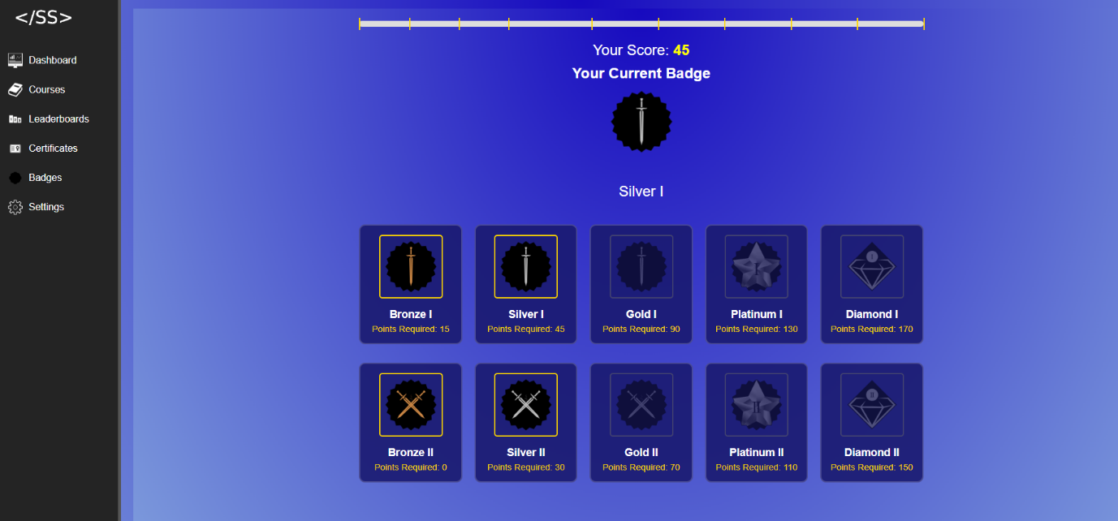

**Tracking Progress with the Progress Bar**

1. On the **badges page**, find the **progress bar** at the top.
2. If you hover over the **progress markers**, a **tooltip** will appear:
   * It will show the **remaining points needed** for the next badge.
   * If a badge is **already earned**, the tooltip will display **"Achieved"**.

**Understanding Locked and Unlocked Badges**

1. If you **haven't earned a badge yet**, it will appear **darker**, indicating it is **locked**.
2. Earned badges will be **highlighted with a gold border** around the image.

**Earning and Unlocking New Badges**

1. Complete a **course** to earn **points**.
2. The **badges page updates dynamically**:
   * If a new badge is unlocked, it will appear **bright and highlighted**.
   * The **progress bar updates** to reflect the new score.
   * The **badge label changes** from "Points Required" to **"Achieved"**.

Troubleshooting:

* **Current badge is not displayed?**
  + Ensure you have completed at least **one course**.
  + Refresh the page or log out and log back in.
* **Badges page does not show all badges?**
  + Scroll down to ensure all badges are visible.
  + Check if your **internet connection** is stable.
* **Progress bar is missing?**
  + Ensure you are **logged in** and have **earned points**.
  + Try refreshing the page.
* **A new badge did not unlock after earning points?**
  + Check if the **correct number of points** was added.
  + Refresh the page or log out and log in again.

3.13 Leaderboard

Overview:

The leaderboard displays the top users ranked by their total score, allowing users to compare their progress with others. Users can customize the leaderboard view based on the number of users displayed and choose between a global or friends-only leaderboard.

Steps:

1. When the user navigates to the leaderboard page, they will see a list of users sorted from highest to lowest score.
2. The user can select how many top users to display (5, 10, 50, 1000) using the dropdown menu.
3. The user can switch between the **Global Leaderboard** (showing all users) and the **Friends Leaderboard**(showing only their added friends).
4. The leaderboard updates dynamically when scores change.

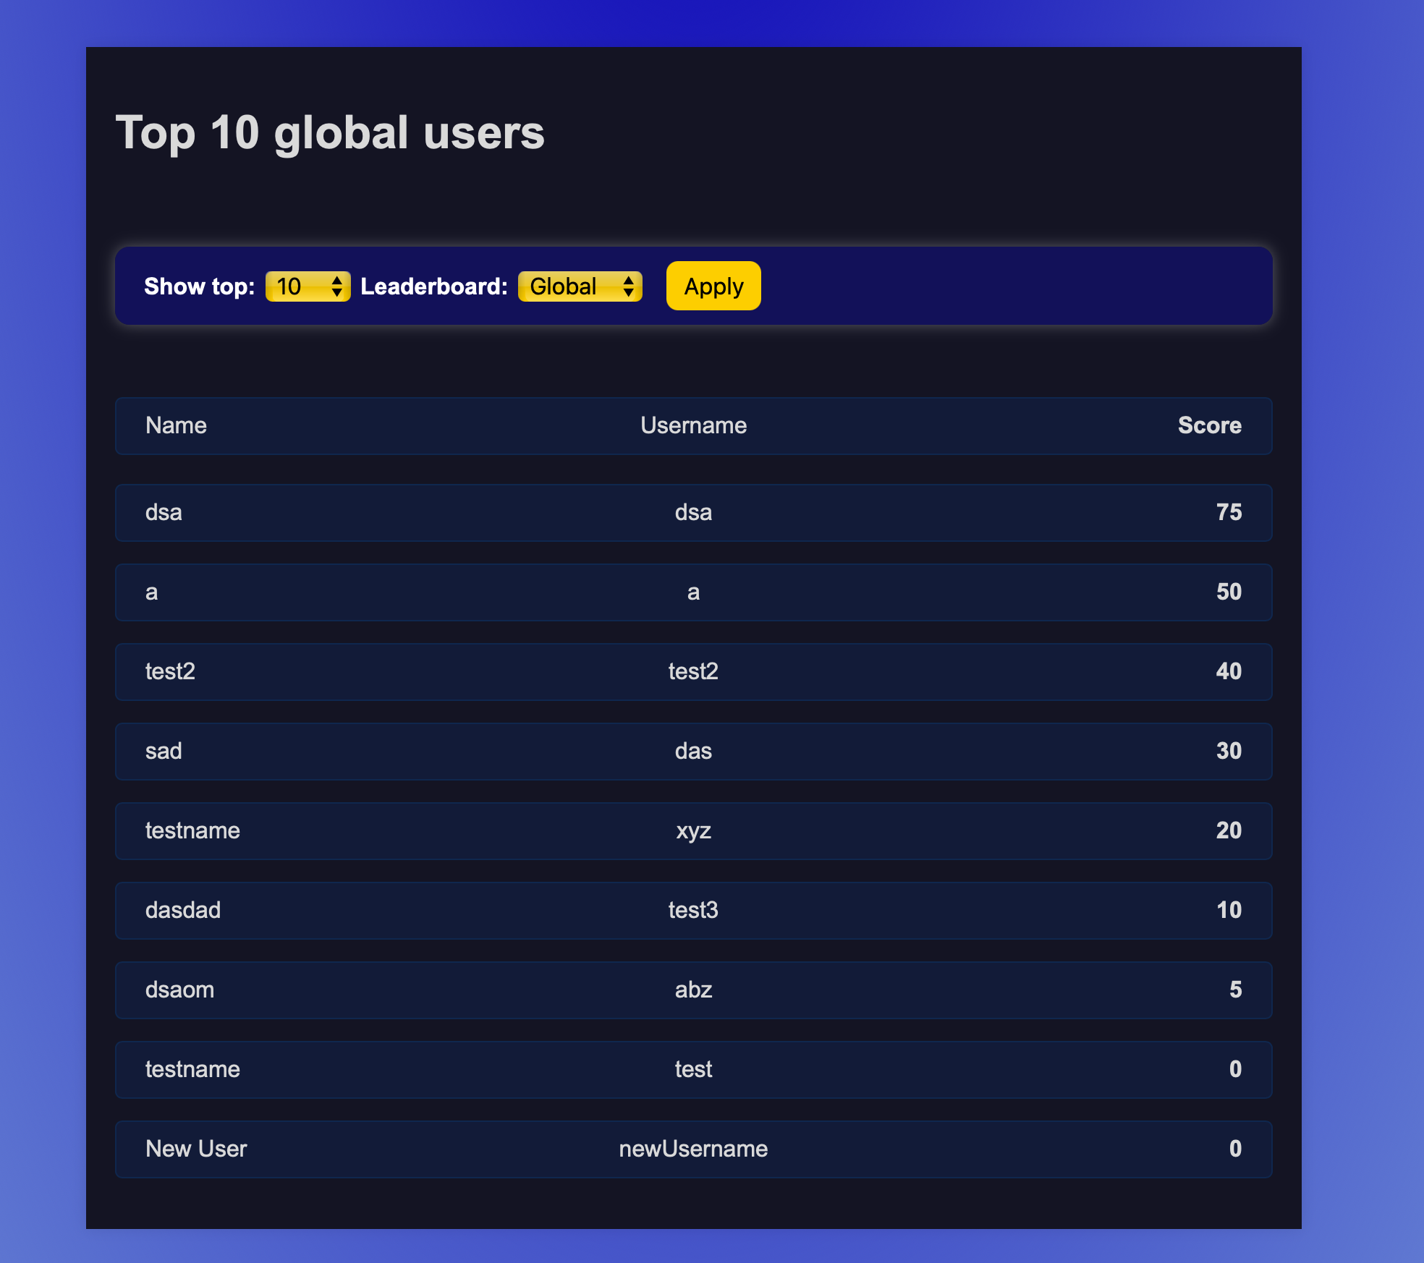

Troubleshooting:

* If the leaderboard does not update immediately, refresh the page to see the latest rankings.
* If a user is missing from the Friends Leaderboard, ensure they are added as a friend.

If the leaderboard does not load, check the internet connection and try again.

3.14 Email Notification System

Overview:

This feature allows users to sign up for an account and automatically receive daily reminders to complete their courses. Upon registration, users are added to the notification system, ensuring they stay on track with their learning progress.

Steps:

**Sign Up**

1. Navigate to the **Sign-Up** page.
2. Enter the following details:
   * **Full Name**
   * **Email Address**
   * **Password**
   * **Username**
3. Click **Register** to complete the process.
4. Once registered, you will automatically be added to the notification system.

**Daily Reminders**

* Every day at **9:00 AM**, you will receive an email reminder to continue your courses.

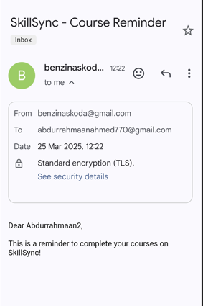

* These emails are automated and cannot be replied to.

Troubleshooting:

* **Didn’t receive a reminder?**
  + Check your **spam/junk** folder.
  + Ensure you registered with the correct email.
* **Having trouble signing up?**
  + Make sure all required fields are filled correctly.
  + Use a strong password that meets security requirements.

3.15 Chatbot

Overview:

The user will be able to get answers for their questions and information about the site from a chatbot.

Steps:

**Access chatbot:** Open a supported page on the website and click on the chatbot icon in the bottom right corner of the page.

(Supported pages: Landing, Dashboard, Login/Register, Courses, Certificates, Leaderboard, Quiz, Settings)

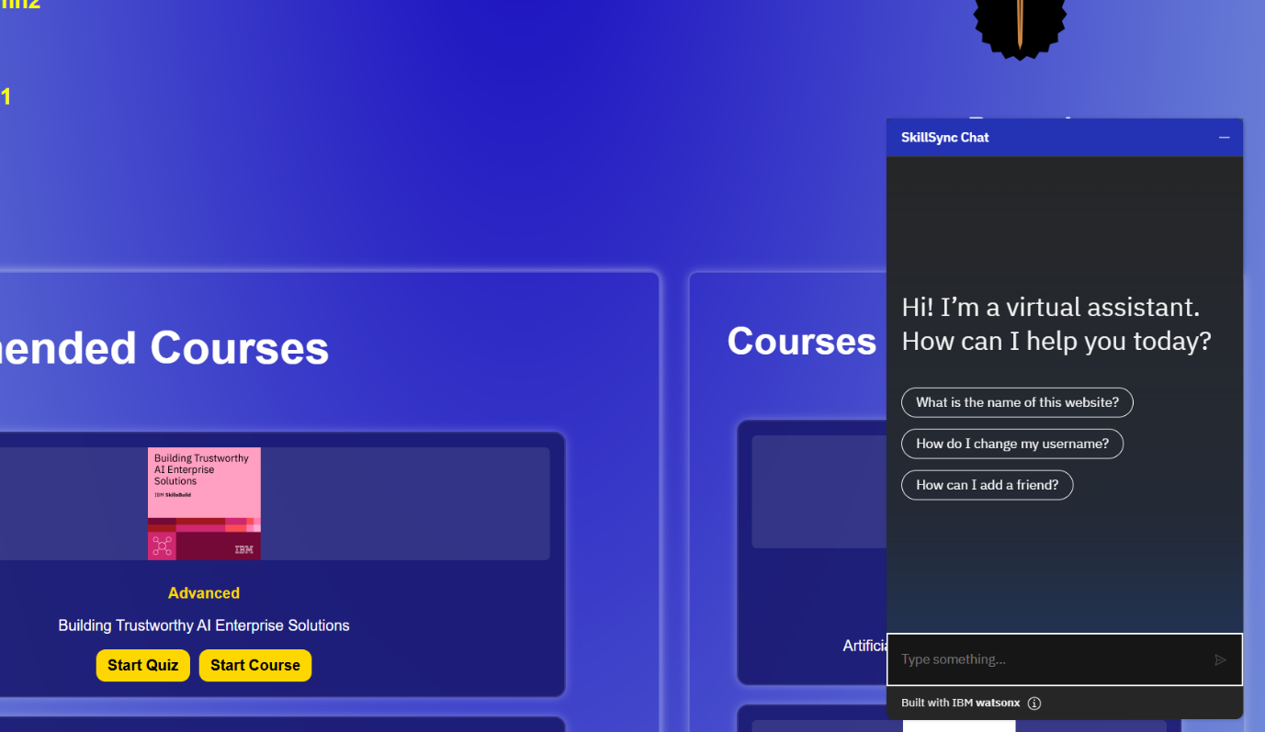

**Ask questions:** The user can input their query into the text box in the chatbot window and press enter to send the message.

The user should then receive a reply from the chatbot.

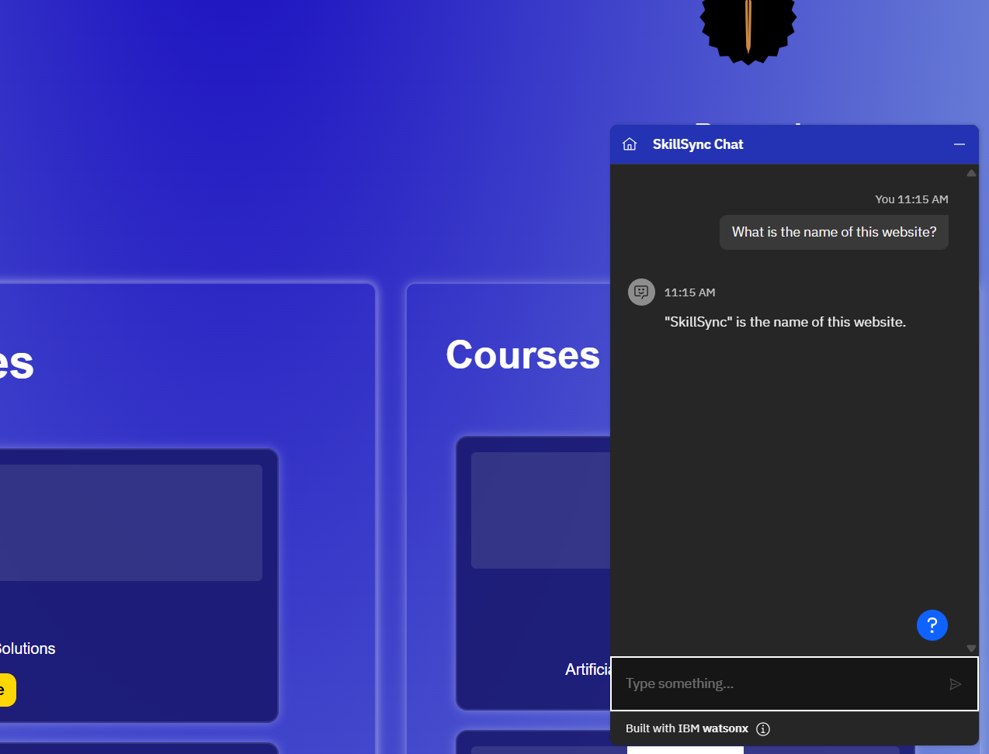

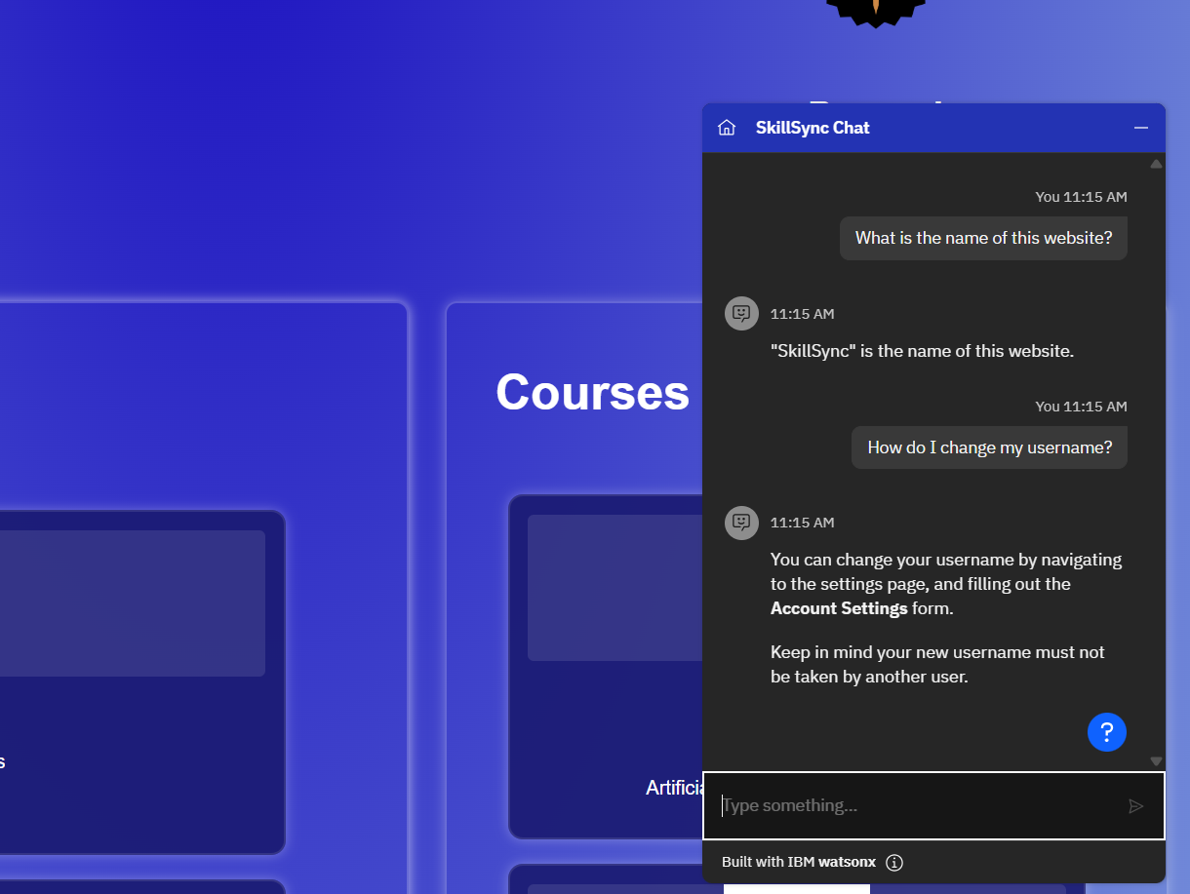

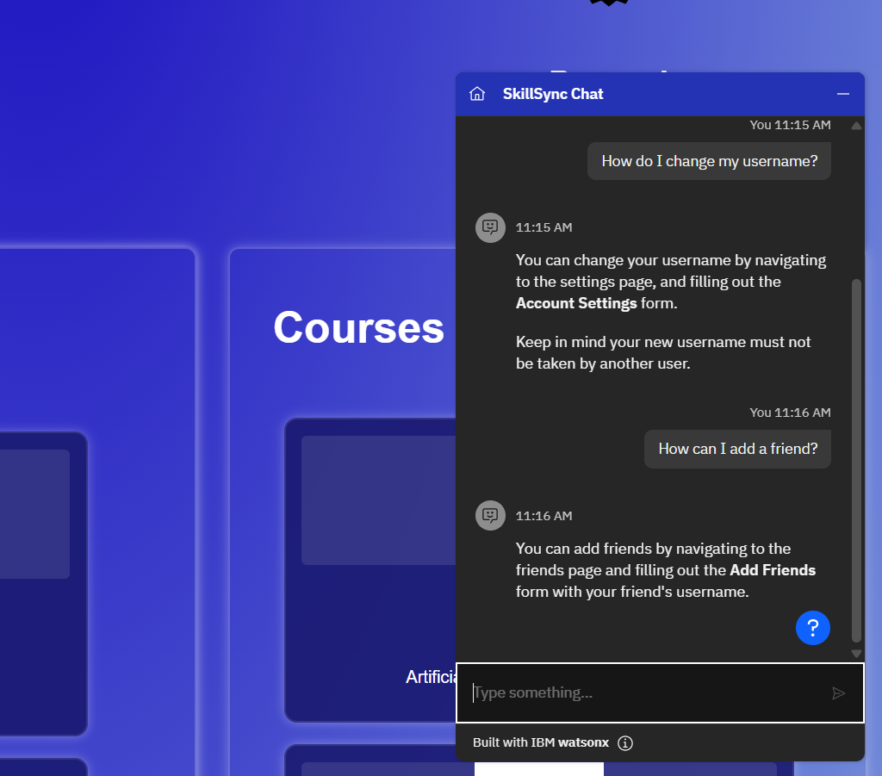

Troubleshooting:

* If the user cannot see the chatbot icon, they should try reloading the page. They should also ensure they are on a supported page.
* The chatbot can only answer certain questions so some questions may not get a correct response.

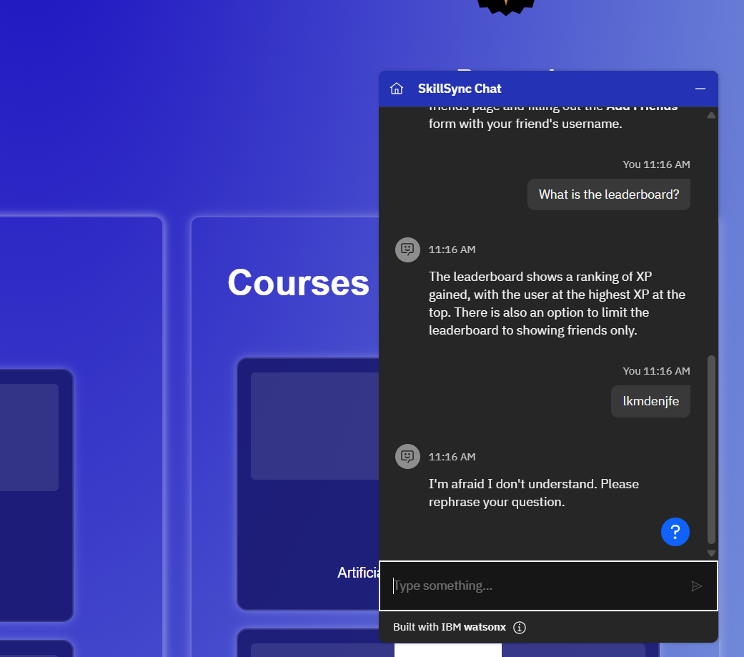

Any issues with the chatbot not loading / errors may need to be forwarded to IBM, as the chatbot is designed by them.

3.16 Website Responsiveness

Overview:

This feature ensures a consistent user experience across different devices, including mobile phones and tablets. Key adjustments include a portrait view on mobile, optimized column layout on tablets, and a hamburger menu for navigation on smaller screens.

Steps:

**Using the Website on a Mobile Device**

1. Open the website on your **mobile browser**.
2. The content will automatically adjust to **portrait mode** for better readability.
3. The website will display all content in **a single-column format**, ensuring smooth navigation.
4. All website functions will remain accessible without display issues.

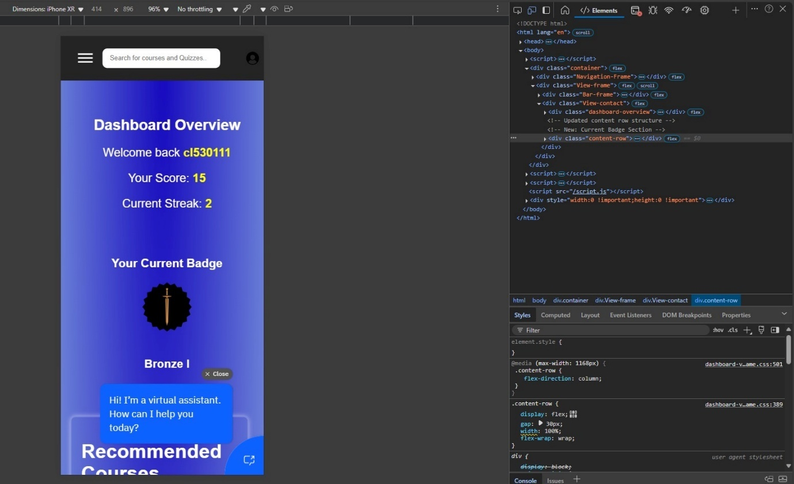

**Using the Website on a Tablet**

1. Open the website on your **tablet browser**.
2. The content layout will adjust for **better readability** on a smaller screen.
3. The display ensures that **columns do not overlap**, maintaining a clear and structured view.

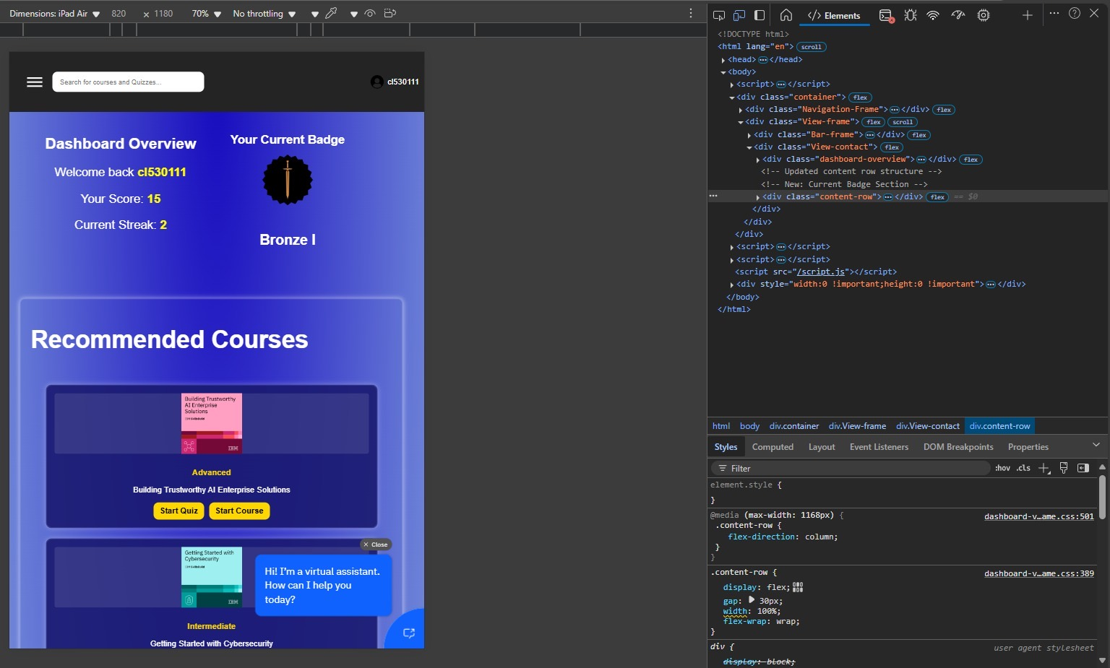

**Accessing the Menu on a Small Display**

1. On **mobile or tablet**, locate the **hamburger menu icon** (☰) in the **top left corner**.
2. Tap the icon to **open the menu**.
3. Use the menu as usual to **navigate between pages**.

**Using the Website on a Tablet**

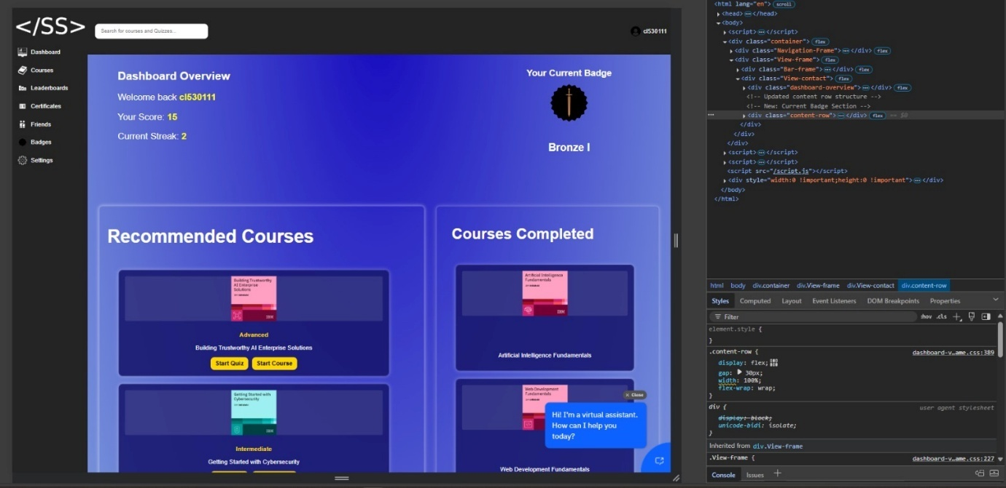

Troubleshooting:

* **Content is not displaying correctly on mobile/tablet?**
  + Try refreshing the page or clearing the browser cache.
  + Ensure your browser is updated to the latest version.
* **Columns are overlapping on a tablet?**
  + Rotate your device to landscape mode and check if the issue persists.
  + Report the issue if it continues after reloading.

# 4. Gamification Overview (check Glossary in Appendix for further information)

* Certificates:  
  - Certificates are awarded automatically when you pass a course quiz, encouraging users to undertake courses, quizzes and serving as evidence of your learning achievements.  
  - The certificates page allows you to review these awards by filtering them based on course category and difficulty, and sorting by recency.  
  - This visual record helps motivate continued learning and progress tracking.
* badges, streaks, leaderboards:  
  - Users are able to earn badges based on progress and goals, motivating the learning.

-Users are able to keep track and maintain streaks by logging in daily.

-Users are able to see a leaderboard where they can compare my progress with friends, and a global leaderboard as well.

# 5. Maintaining the User Manual

* Update Regularly:  
   - As new features are developed, add new sections and update existing ones.
* Version Control:  
   - Make sure to store this manual in the repository (e.g., under a docs/ folder) to ensure it is version-controlled and up-to-date.
* Screenshots:  
   - Update screenshots as UI changes occur.

# 6. Troubleshooting and FAQs

* No Certificates Displayed:  
   - Ensure that you have completed courses and passed quizzes.  
   - Check that filtering options are not overly restrictive.
* Login Issues:  
   - Verify your credentials and check for browser cache issues.
* UI Inconsistencies:  
   - Make sure you’re using the latest version of the manual; clear cache if needed.

# 7. Appendix

* Contact Information:  
   -Email: sjk50@student.le.ac.uk
* Glossary:  
   - Certificate: A record of successful course completion and quiz pass.  
   - Enrollment: Registration for a course.  
   - Gamification: Incorporation of game-like elements (certificates, badges) to motivate learning.
* Change Log:  
   - Document updates to this manual with version numbers and dates.